
2015 NEW PRODUCTS

HOLSTERS
A.R.C. IWB HOLSTER

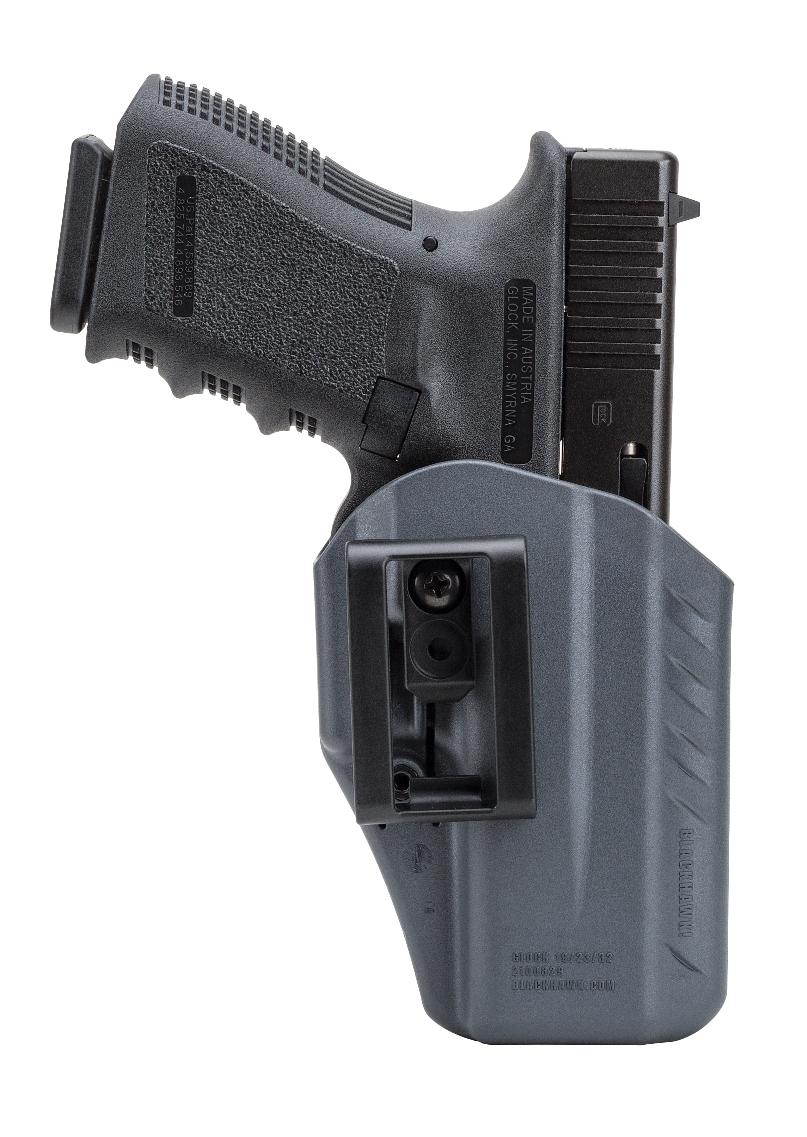
The new Appendix Reversible Carry (A.R.C.) Inside the Waistband (IWB) Holster from BLACKHAWK! is designed for both civilian and law enforcement concealed carry. It is crafted to be extremely versatile and comfortable for those users who prefer the appendix carry position.

The A.R.C. IWB Holster is designed to be as comfortable as it is functional. The Urban Grey holster body is constructed of a soft, yet durable, injection-molded polymer material for all-day comfort. The fully reversible and ambidextrous holster accommodates left- and right-handed users and is packaged with two cant and ride height adjustment belt clips for 1.5- and 1.75-inch belts.

A passive retention detent with adjustment screw allows users to vary the amount of friction for personalized firearm security. The holster can be used in conjunction with pistols featuring rear-mounted red dot sights. The new A.R.C. IWB Holster presents both law enforcement and civilians with a deep concealment holster at an economic price.

Features:
- Soft yet durable injection-molded polymer material for comfort
- Fully ambidextrous design allows for left- and right-hand use
- Includes two cant and ride height adjustment belt clips for 1.5”
to 1.75” belts
- Passive retention detent with adjustment screw
- Allows for use of rear-mounted red dots
- Made In USA

Part No. | Description | Colors | UPC |  | MSRP
417500UG | Glock 17/22/31, Ambi, | Urban Grey | 6-04544-61557-9 |  | $22.45
417502UG | Glock 19/23/32, Ambi, | Urban Grey | 6-04544-61558-6 |  | $22.45
417563UG | S&W M&P Shield, Ambi | Urban Grey | 6-04544-61559-3 |  | $22.45
417567UG | Glock 42, Ambi | Urban Grey | 6-04544-61560-9 |  | $22.45

